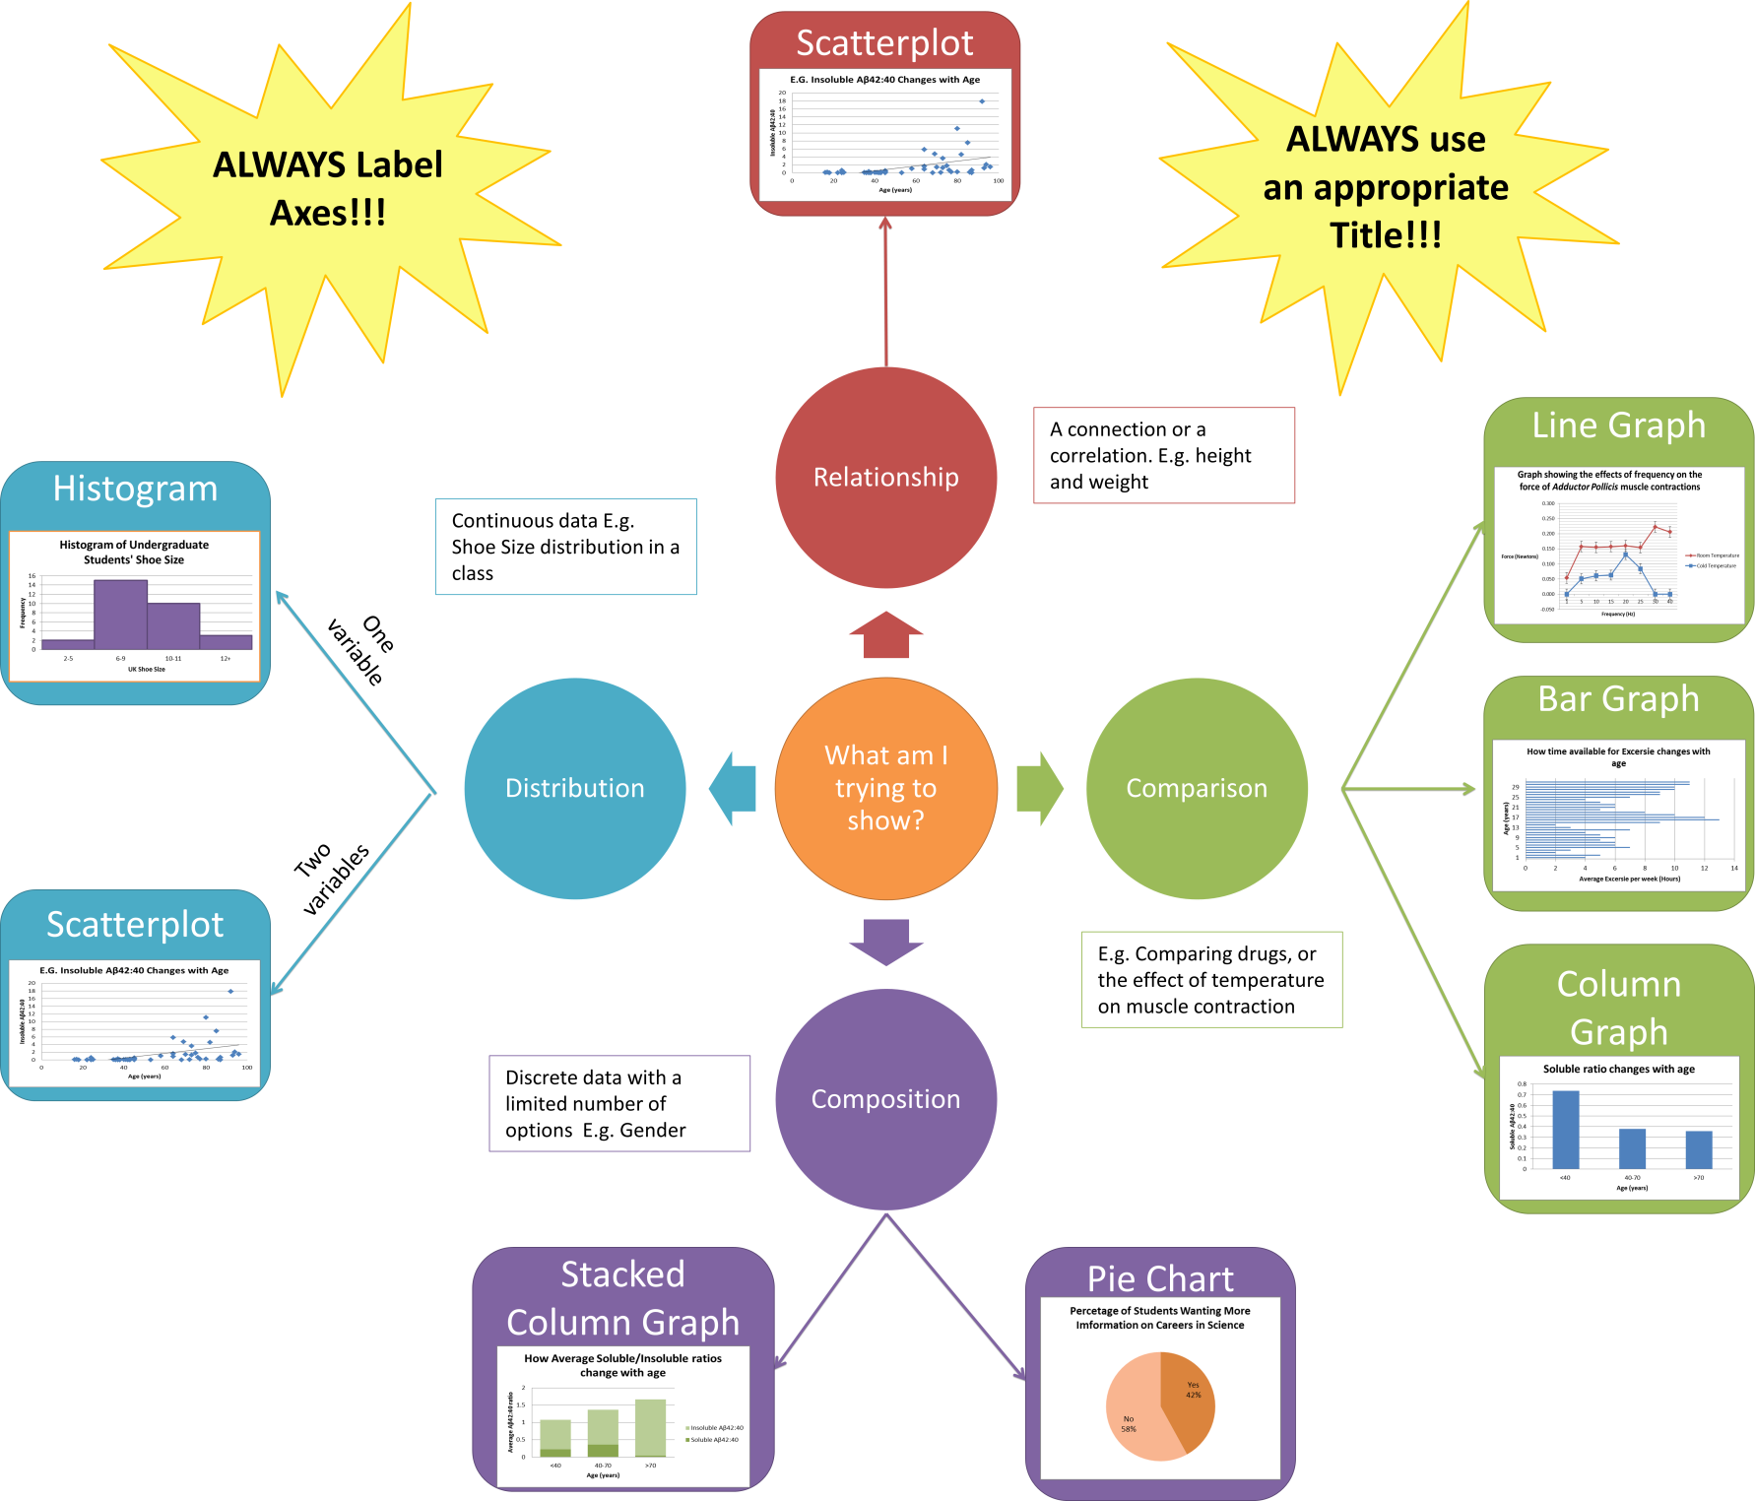

How to make a:
*Make sure that the Analysis ‘add on’ is active in your Excel- Instructions are at the start of the first video link*

How to Plot Error bars (and why you need to bother with them!):
For Line/Bar/Column graphs you should plot error bars. These error bars allow you to see if your data is statistically significant when you have plotted a mean.
When you plot an average value you are normally only selecting a few individuals out of a larger population, and therefore your average is biased depending on who you selected. E.g. If you are trying to find the mean shoe size of a population of 100 by selecting 5 people the value of your mean will change slightly depending on which 5 people are randomly picked.
Error bars, like the standard deviation/error bars, show the highest possible mean and the lowest possible mean value possible across the entire population.
*** Don’t worry if you don’t understand this, lots of Undergraduate students struggle to understand the maths behind error bars***

All you need to understand is that:
- If the Error bars overlap, as shown in the picture to the right, then the means are not significantly different.
- If the error bars do not overlap (as shown to the right) then it suggests that the means are significantly different. Though it is always best to confirm it with a Statistical Test…

Here’s how to plot error bars in Excel:
Calculate the average (=AVERAGE), standard deviation (=STDEV) and the standard error to get these values:
 | Soluble Aβ42:40 |  |  | Insoluble Aβ42:40
Age (years) | <40 | 40-70 | >70 | <40 | 40-70 | >70
Average ratio | 0.735605 | 0.377017 | 0.358294 | 0.114795 | 0.99487 | 3.205968
Standard Deviation | 0.392599 | 0.298904 | 0.211599 | 0.167993 | 1.704841 | 4.825132
Standard Error | 0.130866 | 0.070452 | 0.0529 | 0.046593 | 0.413485 | 1.170266

N.B. The standard error about the mean is calculated using the following formula:
$$=\frac{Standard Deviation}{\sqrt{n}}$$
Which translates in Excel to =STDEV/(SQRT(number of numbers))
- When you plot the average against the soluble ratio, you should get a graph like this:
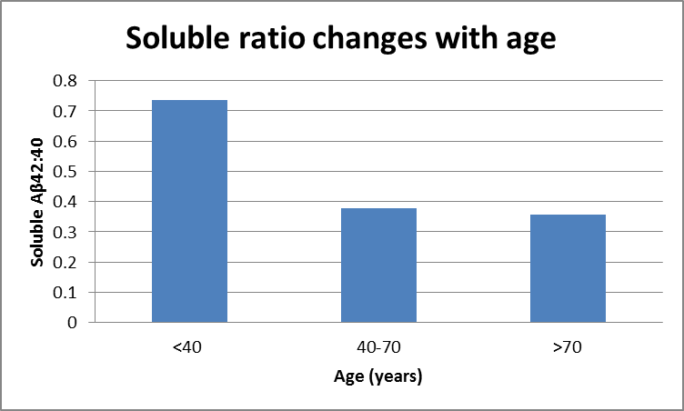
To add the Standard Error bars you need to do the following:
Under ‘Chart Tools’ select ‘Layout’ > Error Bars > Error Bars with Standard Error.
This will give you the error bars, though they will not yet have your standard error values they will all be the same. To change this right click the error bar, which should bring up this menu:
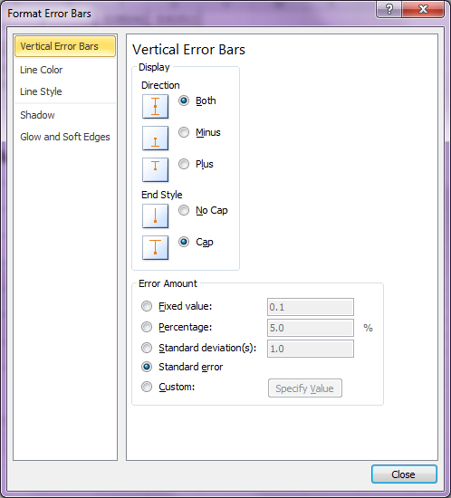
Then select ‘Custom’, and ‘Specify Value’. Then select the cells that contain the standard error values you calculated earlier, for both the positive and negative error values.

Now you have a correct Column graph displaying the average ratio for each age group and the standard error values either side, something like this:

