# Teacher’s answers and ‘how to’ guide:

1. Calculating the soluble and insoluble Aβ42:40 ratios. For the soluble ratio “=Soluble Aβ42/ Soluble Aβ40” and the insoluble ratio “=Insoluble Aβ42/ Insoluble Aβ40” and drag the formulas down. These are the values you should get (to two decimal places):

|  |  |  |
| --- | --- | --- |
| **Soluble Aβ42:40** | **Insoluble Aβ42:40** | **AGE** |
| 0.22 | 0.86 | 64 |
| 0.36 | 1.01 | 58 |
| 0.04 | 1.63 | 64 |
| 0.22 | 5.85 | 64 |
| 0.35 | 11.08 | 80 |
| 0.40 | 1.41 | 70 |
| 0.22 | 1.75 | 75 |
| 0.99 | 4.71 | 69 |
| 0.13 | 1.27 | 73 |
|  | 4.61 | 82 |
| 0.20 | 0.17 | 43 |
| 0.19 | 0.04 | 53 |
| 0.41 | 0.08 | 72 |
| 0.71 | 0.65 | 76 |
| 0.21 | 3.64 | 73 |
| 0.23 | 1.19 | 93 |
| 0.28 | 0.25 | 80 |
| 0.24 | 2.08 | 94 |
| 0.41 | 17.89 | 92 |
| 0.72 | 0.64 | 87 |
| 0.77 | 7.51 | 85 |
| 0.31 | 0.26 | 77 |
| 0.45 | 0.01 | 87 |
| 0.18 | 0.13 | 86 |
| 0.12 | 0.02 | 68 |
| 0.10 | 1.45 | 96 |
| 0.87 | 0.10 | 16 |
|  | 0.08 | 35 |
| 0.02 | 0.33 | 45 |
| 0.65 | 0.56 | 45 |
| 0.82 | 0.09 | 40 |
| 0.73 | 0.12 | 41 |
|  | 0.04 | 37 |
| 0.80 | 0.03 | 36 |
| 0.68 | 0.01 | 42 |
| 0.81 | 0.03 | 24 |
| 0.15 | 0.04 | 45 |
| 0.16 | 0.01 | 38 |
|  | 0.03 | 18 |
| 0.52 | 0.02 | 22 |
| 1.62 | 0.05 | 25 |
| 0.55 | 0.03 | 38 |
| 0.67 | 0.03 | 43 |
| 0.12 | 0.02 | 43 |
| 0.57 |  | 20 |
| 0.21 |  | 45 |
| 0.57 | 0.18 | 17 |
| 0.67 | 0.27 | 37 |
|  | 0.62 | 24 |

N.B. If values are missing for an individual then the ratio will be ‘0’, delete these values so they are blank.

1. Plotting a scatterplot graph, that should look like this:

To get the trendlines to appear, right click a data point and select add trendline. Both axis’ should be labelled and should be of an appropriate length, by fixing the values.

1. To make the graph with 3 separate age groups you should first sort the data by age. Then you should re-arrange the data into a table something like this:

|  |  |  |  |  |  |
| --- | --- | --- | --- | --- | --- |
| **Soluble Aβ42:40** | | | **Insoluble Aβ42:40** | | |
| <40 | 40-70 | >70 | <40 | 40-70 | >70 |
| 0.873198 | 0.824423 | 0.412641 | 0.104076 | 0.09242 | 0.077655 |
| 0.566414 | 0.726946 | 0.126009 | 0.181062 | 0.117345 | 1.268979 |
|  | 0.675128 | 0.209548 | 0.026221 | 0.014154 | 3.642354 |
| 0.56986 | 0.198347 | 0.223193 |  | 0.165663 | 1.748771 |
|  | 0.673407 | 0.709868 | 0.024877 | 0.027852 | 0.65028 |
| 0.808687 | 0.116084 | 0.314476 | 0.027566 | 0.024553 | 0.262882 |
|  | 0.016071 | 0.348378 | 0.615106 | 0.334012 | 11.08372 |
| 1.620488 | 0.64859 | 0.283274 | 0.05485 | 0.564444 | 0.25323 |
|  | 0.152948 |  | 0.083229 | 0.035766 | 4.61053 |
| 0.798861 | 0.208822 | 0.774959 | 0.026042 |  | 7.507909 |
|  | 0.192441 | 0.180805 | 0.036435 | 0.039529 | 0.13408 |
| 0.665883 | 0.355206 | 0.719934 | 0.270133 | 1.007693 | 0.639938 |
| 0.16302 | 0.221289 | 0.447757 | 0.014012 | 0.864727 | 0.009944 |
| 0.554035 | 0.041961 | 0.41106 | 0.028726 | 1.626362 | 17.8881 |
|  | 0.221211 | 0.230298 |  | 5.851534 | 1.19008 |
|  | 0.124095 | 0.238374 |  | 0.022999 | 2.082206 |
|  | 0.991194 | 0.10212 |  | 4.712035 | 1.450793 |
|  | 0.398139 |  |  | 1.411708 |  |

N.B. when you paste the data make sure you paste values and not formulas.

Then calculate the average (=AVERAGE), standard deviation (=STDEV) and the standard error to get these values:

|  |  |  |  |  |  |  |
| --- | --- | --- | --- | --- | --- | --- |
|  | **Soluble Aβ42:40** | | | **Insoluble Aβ42:40** | | |
|  | <40 | 40-70 | >70 | <40 | 40-70 | >70 |
| Average | 0.735605 | 0.377017 | 0.358294 | 0.114795 | 0.99487 | 3.205968 |
| Standard Deviation | 0.392599 | 0.298904 | 0.211599 | 0.167993 | 1.704841 | 4.825132 |
| Standard Error | 0.130866 | 0.070452 | 0.0529 | 0.046593 | 0.413485 | 1.170266 |

N.B. The standard error about the mean is calculated using the following formula:

$$=\frac{Standard Deviation}{\sqrt{n}}$$

Which translates in Excel to =STDEV/(SQRT(COUNT(number in each group)))

1. When you plot the average against the soluble ratio, you should get a graph like this:

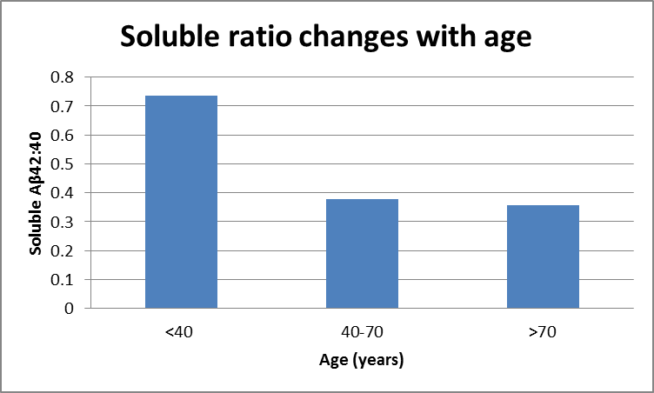

To add the Standard Error bars you need to do the following:

Under ‘Chart Tools’ select ‘Layout’ > Error Bars > Error Bars with Standard Error.

This will give you the error bars, though they will not yet have your standard error values they will all be the same. To change this right click the error bar, which should bring up this menu:

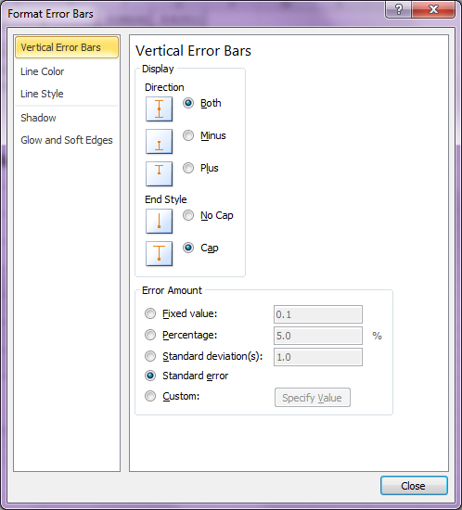

Then select ‘Custom’, and ‘Specify Value’. Then select the cells that contain the standard error values you calculated earlier, for both the positive and negative error values.

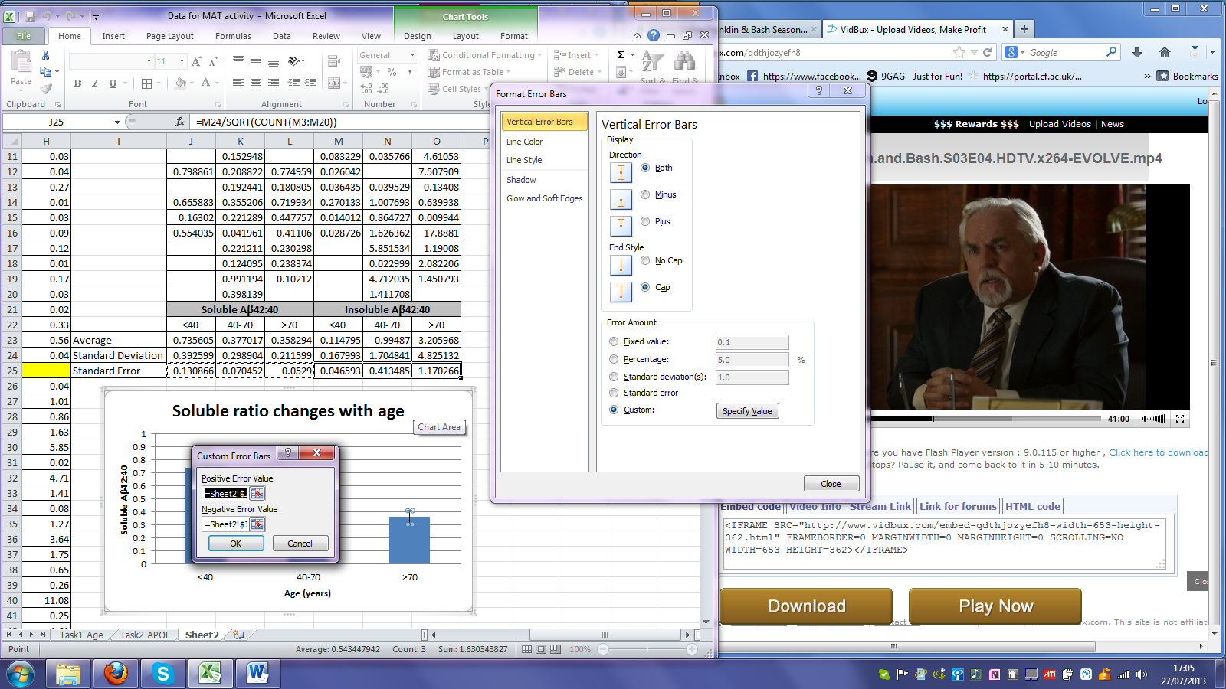

Now you have a correct Column graph displaying the average ratio for each age group and the standard error values either side, something like this:

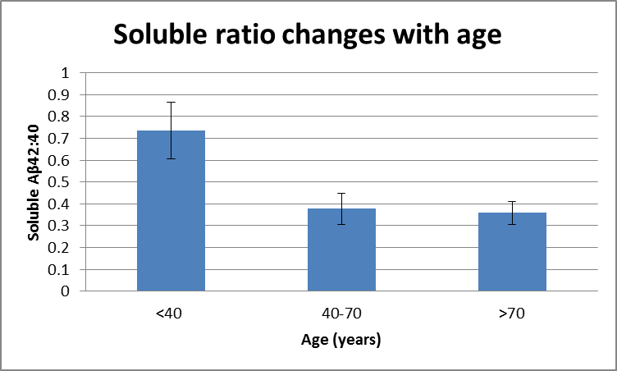

1. And for the insoluble ratio:

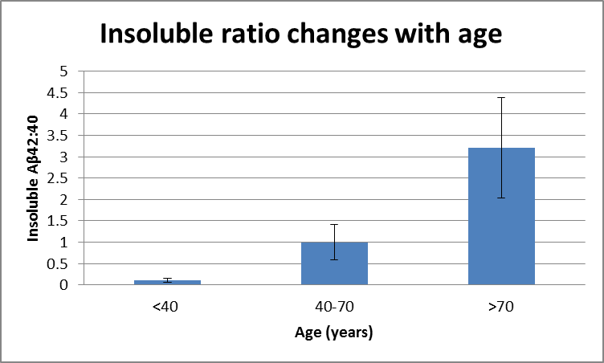

1. For the second task, determining how the ratio changes with APOE genotype, begin by sorting the data by APOE genotype. Then put each genotype in a separate column like so:

|  |  |  |  |  |  |  |  |  |
| --- | --- | --- | --- | --- | --- | --- | --- | --- |
|  | **APOE Genotype Soluble Aβ42:40** | | | | **APOE Genotype Insoluble Aβ42:40** | | | |
| **Age (years)** | 2.2 | 2.3 | 3.3 | 3.4 | 2.2 | 2.3 | 3.3 | 3.4 |
| 68 | 0.12 |  |  |  | 0.02 |  |  |  |
| 58 |  | 0.36 |  |  |  | 1.01 |  |  |
| 93 |  | 0.23 |  |  |  | 1.19 |  |  |
| 94 |  | 0.24 |  |  |  | 2.08 |  |  |
| 87 |  | 0.45 |  |  |  | 0.01 |  |  |
| 64 |  |  | 0.04 |  |  |  | 1.63 |  |
| 64 |  |  | 0.22 |  |  |  | 5.85 |  |
| 70 |  |  | 0.40 |  |  |  | 1.41 |  |
| 75 |  |  | 0.22 |  |  |  | 1.75 |  |
| 69 |  |  | 0.99 |  |  |  | 4.71 |  |
| 73 |  |  | 0.13 |  |  |  | 1.27 |  |
| 82 |  |  |  |  |  |  | 4.61 |  |
| 43 |  |  | 0.20 |  |  |  | 0.17 |  |
| 53 |  |  | 0.19 |  |  |  | 0.04 |  |
| 72 |  |  | 0.41 |  |  |  | 0.08 |  |
| 76 |  |  | 0.71 |  |  |  | 0.65 |  |
| 73 |  |  | 0.21 |  |  |  | 3.64 |  |
| 80 |  |  | 0.28 |  |  |  | 0.25 |  |
| 87 |  |  | 0.72 |  |  |  | 0.64 |  |
| 85 |  |  | 0.77 |  |  |  | 7.51 |  |
| 77 |  |  | 0.31 |  |  |  | 0.26 |  |
| 96 |  |  | 0.10 |  |  |  | 1.45 |  |
| 40 |  |  | 0.82 |  |  |  | 0.09 |  |
| 36 |  |  | 0.80 |  |  |  | 0.03 |  |
| 38 |  |  | 0.16 |  |  |  | 0.01 |  |
| 22 |  |  |  |  |  |  | 0.02 |  |
| 38 |  |  | 0.55 |  |  |  | 0.03 |  |
| 20 |  |  | 0.57 |  |  |  |  |  |
| 45 |  |  | 0.21 |  |  |  |  |  |
| 64 |  |  |  | 0.22 |  |  |  | 0.86 |
| 80 |  |  |  | 0.35 |  |  |  | 11.08 |
| 92 |  |  |  | 0.41 |  |  |  | 17.89 |
| 86 |  |  |  | 0.18 |  |  |  | 0.13 |
| 16 |  |  |  | 0.87 |  |  |  | 0.10 |
| 45 |  |  |  | 0.02 |  |  |  | 0.33 |
| 42 |  |  |  | 0.68 |  |  |  | 0.01 |
| 18 |  |  |  |  |  |  |  | 0.03 |
| 17 |  |  |  | 0.57 |  |  |  | 0.18 |
| 24 |  |  |  |  |  |  |  | 0.62 |

N.B. I excluded all results for which there was no genotype available.

1. Then create two scatterplot graphs (with trendlines):

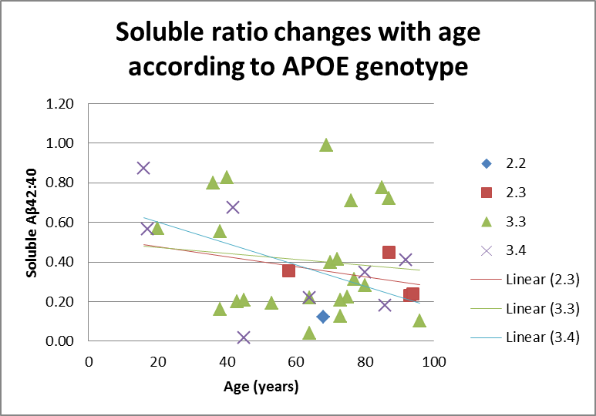

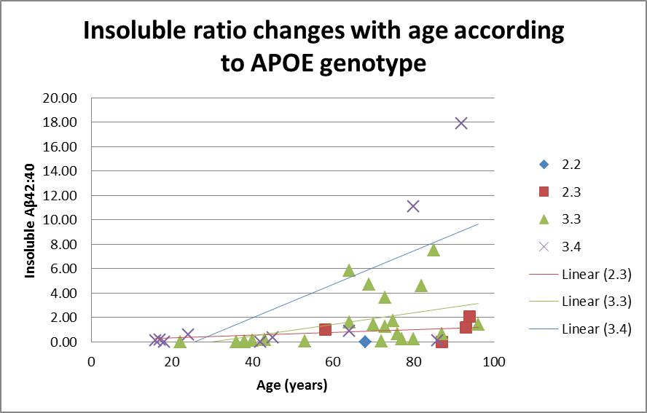

As you can see APOE genotype only slightly affects the soluble ratio, but significantly increases the insoluble ratio especially in those over 60 years old.