A Guide to Ramadan for the Business School

Hi all, I have put together this guide to Ramadan to provide some insight into this month, which many Muslim staff members and students experience.
This guide is written from my perspective as a Muslim colleague experiencing Ramadan whilst working at the university. It is essential to bear in mind that every individual Muslim has their own level and perception of faith, and I do not speak for everyone. This is just how I and many other Muslims experience Ramadan. There will, of course, be some differences individually and internationally.
This guide hopes to be an informative and light-hearted take on the experience of Ramadan. I hope you find it helpful .

What is Ramadan?
For Muslims around the world, Ramadan is a month of fasting. This means that Muslims don’t eat or drink during daylight hours for 30 days. Ramadan is one month of the Islamic calendar. The Islamic Year is based on a lunar calendar, so Ramadan starts 11 days earlier each year according to the Gregorian calendar. Ramadan will, therefore, eventually move through all the seasons. During winter, the fasting days are short; during summer, they can be …very…very…long…! The end of Ramadan is celebrated with a festival called Eid-ul-Fitr.

Is it healthy?
Fasting can have many health benefits for the body, and in recent years, this has become a widespread practice among many individuals and communities. A lot of research is available on this. The main reasons for fasting for Ramadan are unrelated to health or weight loss! It is not healthy for every individual, and exemptions are made for them.

Who is exempt?
Certain groups will be permanently exempt from fasting – those with long-term illnesses who cannot fast, the elderly, and children.
Other individuals exempt from fasting must make up the fasts another time, such as those who are temporarily ill or undertaking strenuous travelling.
Similarly, women are temporarily exempt from fasting when pregnant, breastfeeding, or on their period. If you see someone not fasting, please remember that the reason may be very personal. Although some individuals are comfortable speaking openly about their circumstances, it is good to be considerate and avoid casually or unnecessarily enquiring why someone is not fasting.

What is the purpose of fasting?
Fasting is one of the five pillars of Islam, and Muslims fast primarily as an act of worship.
In being hungry and thirsty, Muslims intend to be reminded of their faith and God in all their actions. It is a month to physically and spiritually detox and work towards bettering oneself.
Many Muslims will make personal, spiritual goals this month and hope to take these improvements through the year. For some people, this could be trying to commit time to learning more about their faith; for some, it is about cultivating characteristics such as being more patient or generous; and for some, it could be something as simple as avoiding gossiping or swearing! Those who are usually less practising may try to commit more to their faith in Ramadan.
The discipline needed to withhold food and drink can remind us of our capacity to persevere and have the discipline to make changes in other aspects of our lives. As human beings, we all fall short of our ideals as we face daily challenges in life. Ramadan becomes a time for reflection, and many people enter the month intending to leave it as a better version of themselves. It is a challenging time, but also one that many people look forward to.
It is also a time to be charitable and experience something as a united community, locally and internationally. Many organisations and communities prepare and distribute food for people experiencing poverty to people of all faiths and none. Muslim student societies have often hosted ‘open iftar’ events, meeting in a public place at the time of breaking fast, and each person brings a meal for themselves and one other person. These events are open to all. Families and communities often come together to break the fast in their homes or mosques and pray together – an interaction largely minimised during the COVID-19 pandemic.

What does a fasting day look like?
In the UK this year, the fasting time starts at 5 am. Throughout the month, the time gets earlier each day, beginning as early as 4 am. The time to break the fast will vary from 6-7 pm. This is the first year in a long time that Ramadan has not been affected by daylight savings time, which significantly increases the length of the fast. This year, Muslims might wake up around 3.30 am to have their final meal before the fast begins. This meal is called suhoor. A person will pray the first of their five daily prayers, go back to sleep and then wake up 1-2 hours later, ready for work or lectures, or stay awake depending on their schedule.
After the end of the working day, a person may spend time praying, studying, and reflecting. Time will be spent preparing the iftar meal to break the fast. Families will break their fast together. Starting with water and a date is customary.
Around 8.30 pm, it will be time for the final prayer of the day. In Ramadan, this prayer is called Tarawih and is much longer than the usual night prayer, taking up to an hour.
After the final prayer, it will be time to sleep before waking up again at 3.30 am. Some people may wake up earlier to prepare food for their families. All in all, it is a long day, especially around 9 to 5 workdays, so you may find that someone observing Ramadan appears a little more fatigued than usual. The daylight hours also become longer by the end of the month, which means that the fasting day also extends, and prayer times finish later.

What should I bear in mind during this month? How can I help?
If you would like, you can wish your colleagues and students Ramadan Mubarak (like saying Happy Ramadan or Congratulations, it’s Ramadan)!
If you share an office with a Muslim colleague, please do not go out of your way to change your lunchtime routine. It is part of the spiritual challenge for Muslims to be able to keep their fast despite seeing people eating and drinking as normal. However, be understanding that a fasting colleague may prefer to avoid any food-based social events during this time.
People who usually drink coffee or smoke may struggle with withdrawal when fasting, so it is good to be aware of this.
Muslim staff members (upon collaborating with managers) may take some annual leave or change their hours during this month to adapt to the working day. This helps ensure a good work-life balance, which the University is committed to. I often take some days of annual leave throughout this month to help me make the most of Ramadan. Taking this time off also enables me to avoid becoming too tired so that I can carry on doing my best work.
You may also find me sitting down at lunchtime and resting my eyes. I’ll be trying to get some rest where I can, as evenings are busy! It is good to be mindful of protecting lunch hours even though a fasting person will not have lunch - and avoid overrunning meetings into lunchtime where possible.
When planning work events, try to make sure these don’t clash with the time for breaking the fast so that Muslim colleagues will not be excluded. It is also good to know that students and colleagues may need time and space to observe their daily prayers. You can collaborate with them to help them with these accommodations where possible.

Asking questions
It is essential to be mindful that a Muslim colleague may not wish to be approached as the ‘font of all knowledge’ surrounding Ramadan, and faith will be a very personal thing for some; each person also has differing knowledge, understanding and practice levels.
However, this can be assessed based on your relationship with a person. If questions arise from a sincere and genuine place of interest and curiosity rather than a critical and cynical perspective, most people will not mind.
Thank you to anyone who has taken the time to read this; it is much appreciated. I hope it’s been helpful and enlightening in some way.
If you have any questions about anything in this guide, please feel free to ask me (the top Ramadan FAQ of all time has been answered in the image below ).
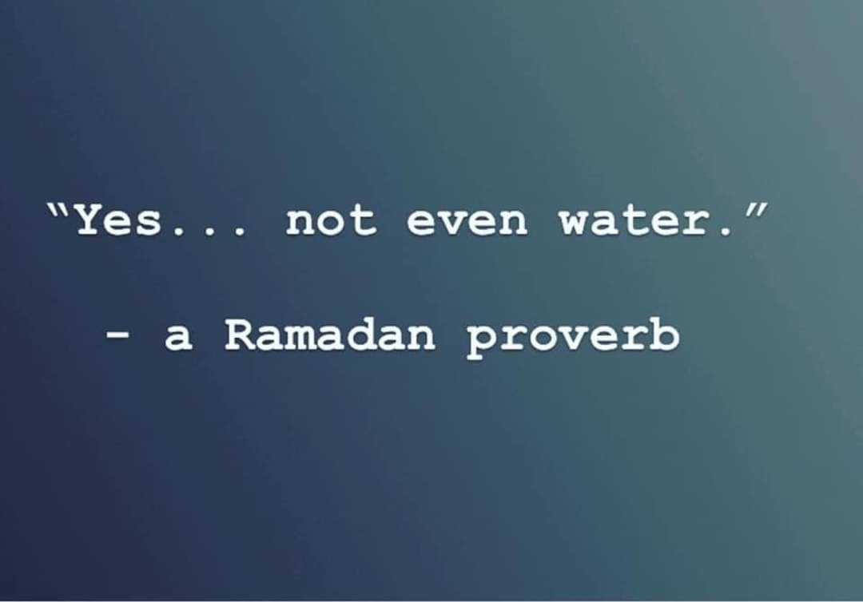
Shaheda Khatun (KhatunS2@cardiff.ac.uk)

