/tmp/lo/0000.doc 23 November 2026 05:24

Third International Workshop on Studies of Expertise and Experience – SEESHOP3

Cardiff University, UK. 14-17th November 2009

Programme (to be finalised)
SATURDAY 14th NOVEMBER ARRIVE
19.00 Table booked in Riverside Cantonese restaurant

NOTES:

Please bring an umbrella! Everywhere is walking distance – around 20 mins -- but it has been known to rain in Britain

November weather in UK can be pretty cold – not freezing but sometimes unpleasant. But it might be quite pleasant.

All accommodation and sustenance other than lunches and coffees are at own expense

Please note that meeting is held in three different locations due to pressure on rooms in term-time.

Email addresses: dfanelli@staffmail.ed.ac.uk, meg3c@virginia.edu,emsgsh@rit.edu, RibeiroR@cf.ac.uk, pross@uottawa.ca, dastone@niu.edu, WeinelM@cf.ac.uk, EvansRJ1@cf.ac.uk, DuarteT@cf.ac.uk, Galindo@cf.ac.uk, CollinsHM@cf.ac.uk, EdwardsA2@cf.ac.uk,

SUNDAY 15th Committee Room 1 of the Glamorgan Bldg (as previous SEESHOPS)
09.00-10.00 Coffee, welcome, introductions
10.00-11.15 | Harry Collins | New conceptual developments  (i) Analysis of Imitation Games (ii) Relationship of practice and language  (iii) Imitation Games and representativeness | Three new developments or ways of thinking to do with Imitation Games and Interactional expertise will be described.  (i) A new and simple method of quantifying results is based on excess of correct guesses over incorrect guesses divided by total guesses makes cross-game comparisons easy. It makes salient the `ethno-method’ features of the game which make cross-culture comparisons possible.  (ii) It will be argued that the possibility of the existence of interactional experts should have been obvious from the outset. It becomes obvious when one thinks harder about what contributory experts actually do. Contributory experts spend most of their lives using interactional expertise! Practice dominates `practices’ at the collective level but only as a result of many small contributions from individuals’ practice all linked together through language. Practice does not dominate individuals’ understanding of `practices.’ There are few purely interactional experts only because the role is hard to attain: the reasons are sociological not logical or philosophical.  (iii) Imitation Games on different topics differ in the extent to which participants need to be carefully selected to be `representative’ of their group. Games on, say blindness and perfect pitch can assume that a haphazardly chosen set of participants will be representative; Games on say gender or religion need to attend much more closely to representatives.
11.15-12.30 | Robert Evans | Imitation Games on Christianity and Coeliac disease | This paper presents the results of two new sets of Imitation Game research. The first follows the now standard Identify and Chance condition format and examines the extent to which active Christians amongst the Cardiff University student population can pass as secular and vice versa. In line with previous research, the Identification Ratios for both conditions are different, suggesting that immersion in the dominant secular culture enables active Christians to reproduce the discourse of secular (student) society. The possibilities of international comparative research on the same topic will also be briefly explored. The second set of results was produced by Helen Boyce for her dissertation project. In this case, the format of the Imitation Game research was changed to only include an single condition in which dieticians involved in the treatment of people living with Coeliac disease were asked to pass as people with the disease. In this case, the aim was to examine the extent to which interactions with patients have enabled dieticians to move beyond bio-medical understanding and appreciate the more social aspects of Coeliac disease. The data show that, overall, the dieticians were able to pass as patients (i.e. the Identification Ratio for the Imitation Games overall was comparable to a Chance condition) but also reveals some interesting variations within the sample group. Whilst it is hard to draw firm conclusions on the basis of the sample used, the data does pilot a new variant of the experimental design and suggest a number of new analytic approaches.
12.30-13.45 Lunch
13.45-15.00 | Adam Edwards | Expertise and Experience in "Preventive Foresight": the case of the European Union's Organised Crime Threat Assessment (OCTA ) | Whereas justice is retrospective in its orientation, establishing guilt for acts already committed, security is future-oriented, concerned with the anticipation or *foresight* of various threats in order to better prevent their actual occurrence. Both generate problems and opportunities for *freedom*; justice through due process seeks the protection of suspects rights to be proven guilty *beyond all reasonable doubt* in an open court of law, but offers victims redress only after their victimisation. Security through preventive foresight offers the prospect of public protection against victimisation in the first instance but often at significant cost to the freedom of movement, assembly, communication, legal rights and so forth of target populations. In the absence of compelling and clearly communicated evidence of the threats to which preventive measures respond, such restrictions on the liberties of citizens are likely to exacerbate problems of legitimacy for the authorities employing these measures, possibly fuelling the very threats they seek to reduce, including the further alienation of target populations. Conversely, it has been argued that some threats to security, for example through acts of terror such as 9/11 or 7/7 and the organisation of other serious crimes, are so chronically uncertain that they escape scientific thinking and require a more creative (artistic?) imagination of threats. How might this dilemma be attenuated through studies of the expertise and experience required for competent, satisficing, preventive foresight? Is satisficing foresight good enough in the face of uncertain, possibly existential, threats? What lessons can be drawn from existing innovations in preventive foresight, such as the European Union*s annual Organised Crime Threat Assessment (OCTA)?
15.00-16.15 | Evan Selinger and David Stone | Exploring Developmental and Pedagogical Dimensions of Interactional Expertise | Our interactive talk is structured around three goals: 1) apprise the audience of new interdisciplinary educational initiatives that have infused interactional expertise into pedagogically innovative proposals related to healthcare management and sustainability; 2) clarify why working on these proposals has bolstered our conviction that greater knowledge needs to be obtained into how interactional expertise is typically acquired; and 3) receive feedback from workshop participants on how to go about improving these initiatives and closing the developmental knowledge gap.
16.15-17.30 | Martin Weinel | What is distinctive about the way SEE impacts on policy? | By introducing Studies in Expertise and Experience (SEE) in their 2002 paper, Collins and Evans have framed SEE as a contribution to technological decision-making (or science-based policy-making). A key element of the proposition is the separation of a technical and a political phase within technological decision-making processes (see also Collins and Evans 2007; Evans and Collins 2007; Evans and Plows 2008). The technical phase is supposed to be reserved for experts (in a broad sense based on the 'theory of expertise'), who are dealing only with propositional questions of a technical or scientific nature. The political phase, in contrast, is open to democratic participation and is supposed to consider much broader political and moral questions. The political phase is also the locus in which final technological decisions are made. This proposition implies that the technical judgements made in the technical phase have to be integrated in some way into the deliberations of the political phase. How exactly this could be done has not yet worked out and is the subject of the presentation.
19.30 Dinner: Piazza Italia (The Hayes)

MONDAY 16th CHANGE OF VENUE: Council Chamber, University Main Building (From Glam Bldg, cross road, then gardens, then road, then upstairs)
8.30-9.45 | Luis Galindo | What kind of expertise is theoretical physics | Philosophy of science has long has long been allowed the final say in what physical theories are and what they aren't. Its views have at times informed and coincided with the opinion of theoretical physicists, but in most cases have been far removed from the actual practice of theoreticians. Social studies of science have mostly neglected physical theory as an object of study, permitting philosophy to construct an idealized and very misinformed picture of what theories in physics look like. Here it is suggested that it is time to develop a sociological perspective on theory based on empirical investigations of what theoreticians actually do in the hope that it will be as enlightening as were the studies of what experimenters actually do. To set the context for this work an initial division of the activities of theoretical physics is developed which is based on the author’s own past experience as a physicist.
9.45-11.00 | Rodrigo Ribeiro | Managing Tacit Knowledge: Levels of Immersion and Similarity | How can we identify and estimate workers' tacit knowledge? How to design a training programme or personnel mix aimed at improving its transfer and development? How to prevent the loss of tacit knowledge due to a foreseeable turn-over or retirement? In order to answer to these questions it is necessary to identify the distinct types of tacit knowledge, what they allow for and their sources. It is also a must to find a way of managing its ‘stock’ and development within the workforce. In short, for managing tacit knowledge we first need a theoretical framework. This paper reports an attempt to build such a framework and apply it to support the pre-operational training and hiring in a US$3 bi industrial plant in Brazil
11.00-11.15 Coffee
11.15-12.30 | Daniele Fanelli | Expertise and the Hierarchy of the Sciences: Should Experts be weighted by the Hardness of their Field? | The concept of a Hierarchy of the Sciences with physical sciences at the top, social sciences at the bottom, and biological sciences somewhere in-between- is nearly 200 years old. This order is hypothesised to reflect the ?hardness? of different fields, manifested in the level of consensus among experts on the significance of new knowledge and the continuing relevance of old. I will outline the controversy around this hypothesis and review the empirical evidence, which is largely in support of it. This leads to the question of whether and how expertise might vary between the sciences and between specific fields of research.
12.30-13.30 Lunch
13.30-14.45 | Philippe Ross | Is There an Expertise of Production? The Case of New Media | This paper extends recent debates in Science and Technology Studies (STS) on long-standing distinctions between expert and layperson to the field of new media. The rise of Web 2.0 has prompted debates around the legitimacy and contributions of professional and amateur producers in fields such as journalism and popular culture, but it also begs the question: what is the substance of the expertise now supposedly under threat by the anonymous, amateur masses? If the production of successful contents and applications is, from the producers’ perspective, a matter of somehow tapping into latent public tastes, needs or demand, can any one group claim exclusive ownership of such a social process? Drawing on a case study of a British publicly-funded production-research laboratory in educational technology, this paper shows how producers debate both the substance of production expertise and the reference group through which would-be producers acquire expertise – is it technical professions relevant to the endeavour or the target audience? It argues that producers are experience-based, ‘interactional experts’ (Collins and Evans 2002; 2007) whose knowledge is (near) ubiquitous and used in an ad hoc manner. As these insights stress opportunity, rather than ability, as a key factor in the mobilization of relevant knowledge in production, they call for further dialogue between STS and media studies on the nature of production and the role of producers in the case of technologies meant for a mass audience.
CHANGE OF VENUE : Glamorgan Bldg Rm 0.12 (In the back right hand corner of the bldg near Cttee Rm 1)
14.45-16.00 | Mike Gorman | Sustainable trading zones | The title has a double-meaning, both aspects of which I will touch in this exploration. Trading zones are an essential part of sustainability, because the concept of sustainability is itself a kind of boundary object—it still has different meanings for different expertises and stakeholders. Out of trading zones may emerge a new expertise in sustainability science that will necessarily involve interactional expertise. Should trading zones be sustained over a long period of time and if so, how? Here I will use my brief experience at the NSF as an example. NSF programs have mechanisms to create trading zones that cut across bureaucratic units, to fund interdisciplinary initiatives and even co-fund individual proposals. Because the scientific and technological frontier changes, old trading zones should morph into new ones, or disappear—which has implications for sustainability science.
16.00-17.15 | Tiago Duarte | Climate change and Bjørn Lomborg’s expertise | The overall context of this presentation is a project on the expertises that have been brought to the discussion of climate change. The broad range of the climate change argument is introduced before moving on to a closer look at one particular protagonist. The Danish political scientist Bjørn Lomborg has carried out an in-depth analysis of climate change. In his books The Skeptical Environmentalist and Cool it, he discusses a number of topics ranging through a cost benefit analysis of policies designed to tackle global warming (such as the Kyoto protocol), the impacts on human societies of a warmer planet, the so-called Hockey-Stick graph, and so on. This presentation raise questions about how Lomborg could have an appropriate level of expertise in all the different topics he debates. Could any such a broad attack on so many aspects of the debate be supported within the theory of expertises?
17.15-  18.00 | FINAL DISCUSSION AND WRAP UP
19.30 Dinner: Wagamama (Cardiff Library – bottom of Hayes)
TUESDAY 17th NOVEMBER DEPART
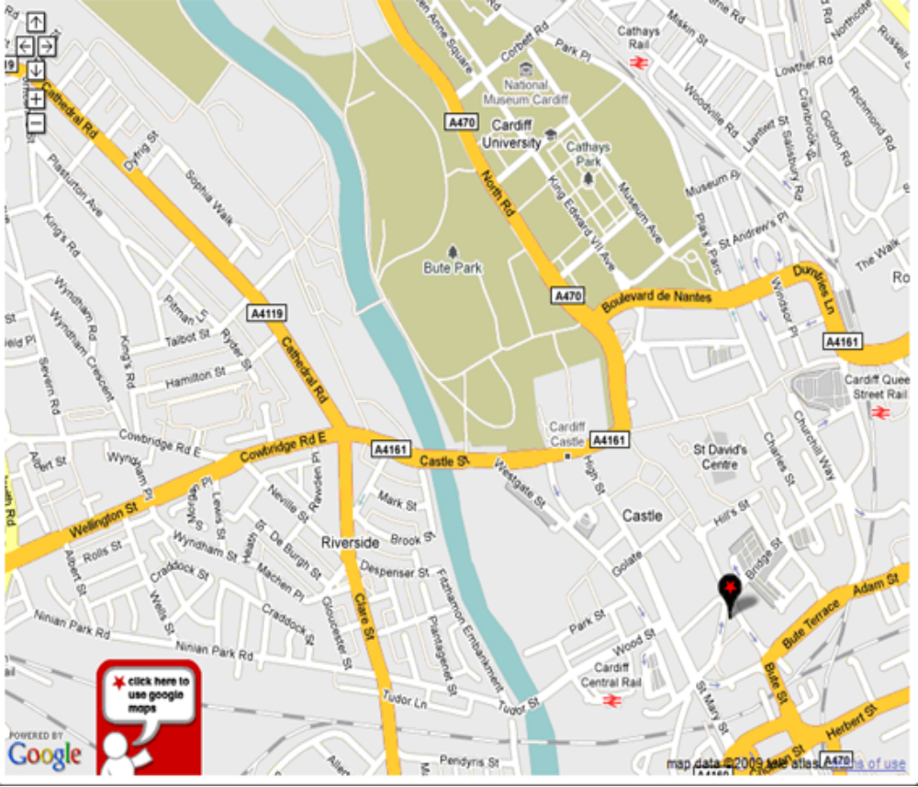
7
1
4
6
2
5
3
KEY: 1) IBIS; 2)Riverside Cantonese; 3) Underpass; 4) Glamorgan Bldg; 5) Piazza; 6) Main Bldg; 7) Waggamama

