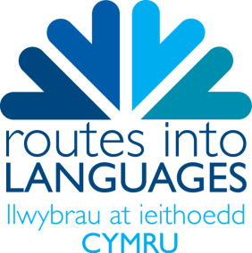
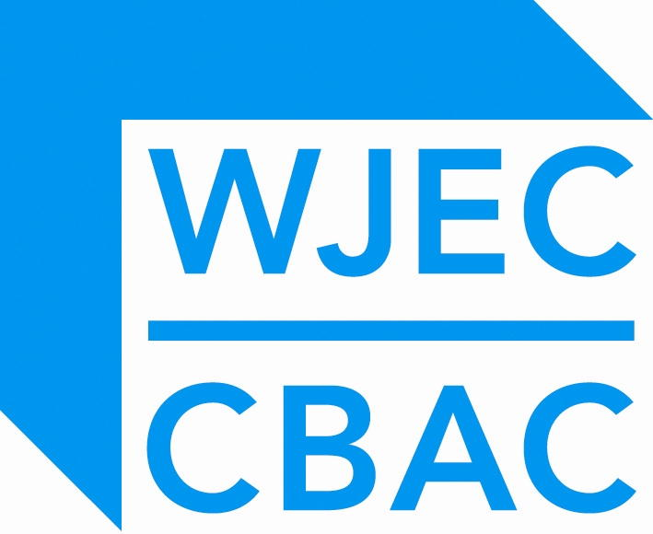
SPELLING IS THE BUZZ WORD
Encouraging Future Linguists
Launching a new resource developed by the WJEC for Routes into Languages Cymru to support students competing in the National Spelling Bee Competition 2014.
Today, Routes into Languages Cymru will launch a fantastic interactive Online Resource that will help and support students in year 7 who are studying French, German, Spanish and Welsh Second Language and competing in the National Spelling Bee Competition 2014. The resource includes alphabet activities in the target language, word games and spelling tests that aim to improve spelling, encourage correct pronunciation and most importantly to raise confidence levels.
By using games and activities we aim to show pupils how language learning can be fun and exciting as well as educational and challenging. Introducing a competitive element has proven to be a key factor in aiding progress and encouraging future linguists to continue with their language learning. There is a section on our New Resource Website where pupils can practice as if competing thus only fuelling their learning bug.
“Making learning fun is the best way to engage with pupils” said Lowri Lewis, Routes Cymru Project Manager. “With this new resource, created by the WJEC to support the National Spelling Bee Competition, pupils can forget that they’re learning and challenge themselves to be the best linguists that they can be, perhaps by becoming the next National Spelling Bee Champion! Language skills are becoming increasingly sought after in the workplace and so we hope that this resource help to give pupils the head start that they deserve.”
Today is the European Day of Languages and what better occasion to launch this brilliant resource and of course The National Spelling Bee Competition itself. Having already received many entries for this year’s competition, we have no doubt that it will be bigger than ever and with this new resource to support entrants, the standard will be even higher.
ENDS
Routes into Languages Cymru: Ani Saunders, Routes Cymru Project Coordinator, email: ani.saunders@ciltcymru.org.uk, tel: 029 2026 5408 / 07854 319557
Interviews with Ceri James, Director of Routes Cymru are available on request from Ani Saunders.

Notes for editors:

- The competition is organised by Routes into Languages Cymru.
- The concept of a multi-lingual Spelling Bee was devised by Jane Driver, a languages teacher in Cambridgeshire. Year 7 pupils are also competing in a National Competition in England which is running in parallel to the competition in Wales.
- The Routes into Languages programme was developed by three organisations working in partnership: the University Council of Modern Languages (UCML), the HE Academy Subject Centre for Languages, Linguistics and Area Studies (LLAS) and CILT, the National Centre for Languages. The Routes into Languages programme is coordinated by a team at the University of Southampton, directed by Professor Michael Kelly. http://www.routesintolanguages.ac.uk/
- Routes into Languages Cymru is funded by the Higher Education Funding Council for Wales (HEFCW) and WJEC.
- Led by CILT Cymru in partnership with 10 universities across Wales, the specific aim of the Routes into Languages Cymru project is to increase the take up of languages from school to university. It encourages young people to have a positive attitude towards their language learning and promotes languages as an essential skill.
- CILT Cymru is funded by the Welsh Government and is managed by WJEC.

